#PeaceByPiece 2021 Social Media Toolkit

Note -- @ symbol is an indication to tag / try to tag individuals/organizations
Link to images: https://scc247.sharepoint.com/:f:/g/ErEETAmfbBpNjKF944rJz-MBPFA2SF7M-RIqV-B90J61mw?e=Eci3UF

HASHTAGS:
- Campaign (Oct – Dec): #PeacebyPiece #ViolenceFreeSC
- DVAM (October Only): #DVAM2021 #SCDVAM #Every1KnowsSome1
- Giving Tuesday (November 30th Only): #GivingTuesday #GivetoEndDV

SAMPLE SOCIAL MEDIA POSTS:

- MAIN image showcasing multiple “pieces” of the puzzle

As we kick-off #DVAM2021, join us in picturing a #ViolenceFreeSC by becoming an integral piece of the puzzle to bring peace to survivors of domestic and sexual violence. By investing @SCCADVASA’s work, you can help to solve the puzzle. Donate now and/or share this post, tagging 3 friends and encouraging them to do the same. #PeacebyPiece https://www.sccadvasa.org/donate/

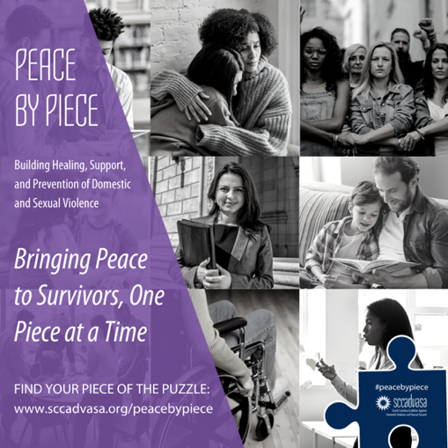

- Business Partner

#Every1KnowsSome1 and businesses recognize that interpersonal violence has negative impacts on the economy, the workforce, and even on their employees. As we begin #DVAM, we ask that you consider investing in the vision of a #ViolenceFreeSC by joining @SCCADVASA’s #peacebypiece campaign as a corporate sponsor. https://www.sccadvasa.org/peacebypiece/

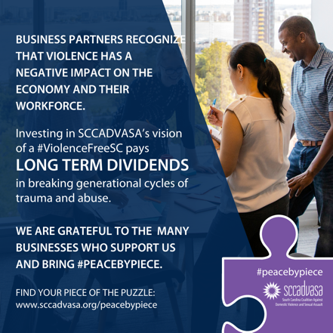

- Parents

As parents, we can have a great deal of influence on our children’s future relationships. By teaching conflict resolution and open communication, we become a part of the solution. Parents are a critical part of breaking the cycle of generational violence. Find resources to help build #peacebypiece through your children at levelupforchange.org and make a donation today to support @SCCADVASA’s prevention work for a #ViolenceFreeSC https://www.sccadvasa.org/donate/

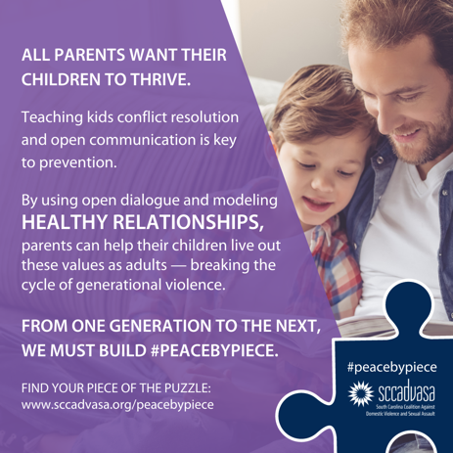

- Pro Bono Attorney

Pro Bono attorneys for victims/survivors provide a key piece of the puzzle to ending intimate partner violence by helping families navigate complex legal systems. A donation to @SCCADVASA supports legal counsel for victims of domestic & sexual violence. We ask you to join today in their efforts to bring #peacebypiece. https://www.sccadvasa.org/donate/

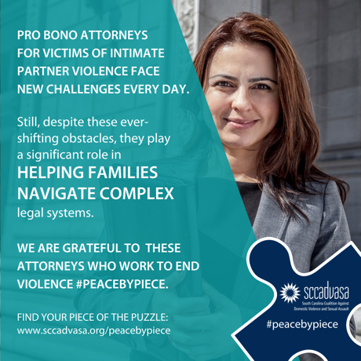

- Accessibility Partner

.@SCCADVASA works closely with Member Organizations to ensure the needs of all survivors are met. Making a commitment to accessibility is just one piece of the puzzle to help break the cycle of violence for those with disabilities, who are 3x more likely to experience violent victimization. Donate today to help support these survivors #peacebypiece. https://www.sccadvasa.org/donate/

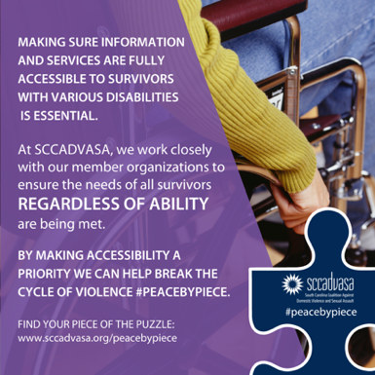

- Friend

Being a friend to a survivor of intimate partner violence is not easy, but friends and family play a critical role in a victim’s journey towards healing. Your piece of the puzzle means listening, being present and providing support without judgement. Because #Every1KnowsSome1, we ask you to expand your impact #peacebypiece and donate now to support @SCCADVASA’s work for a #ViolenceFreeSC. https://www.sccadvasa.org/donate/

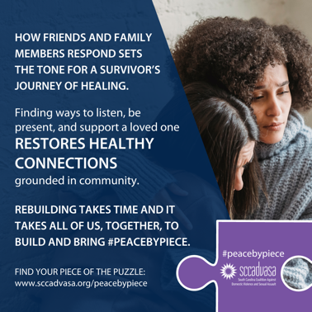

- Advocate

Your voice is a powerful thing. You can speak up for others by communicating with your elected officials the importance of providing support to victims of domestic and sexual violence. Use your voice, #StandWithSurivors and help bring #peacebypiece. Want to do more? Donate to @SCCADVASA and support our advocacy work at both the state and federal level. https://www.sccadvasa.org/donate/

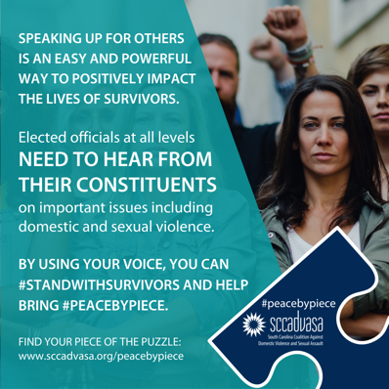

- Training/Ongoing Ed

.@SCCADVASA Member Organizations are staffed by hundreds of direct service providers who ensure survivors get the help they need. By providing ongoing education, we enhance their knowledge, skills, and capacities to enable #peacebypiece for survivors. Donate now to support their work in training & education work with members and local communities across S.C. https://www.sccadvasa.org/donate/

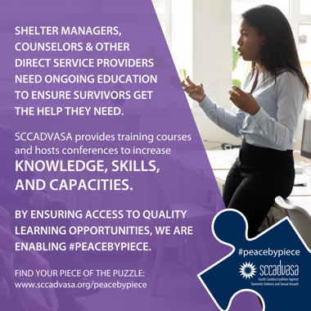

- Donor

By making a financial gift to @SCCADVASA, you are supporting ongoing efforts that improve outcomes for survivors across S.C. We humbly ask that you consider becoming an integral piece of the puzzle to bring peace to survivors of domestic and sexual violence. Your investment, whether it’s $5 or $500, builds #peacebypiece. https://www.sccadvasa.org/peacebypiece/

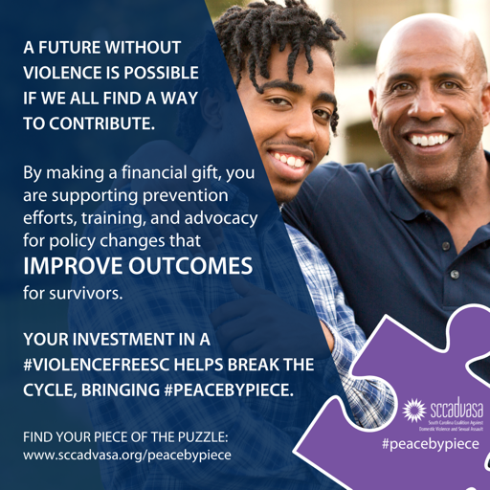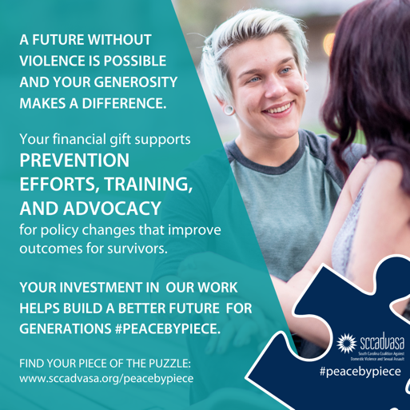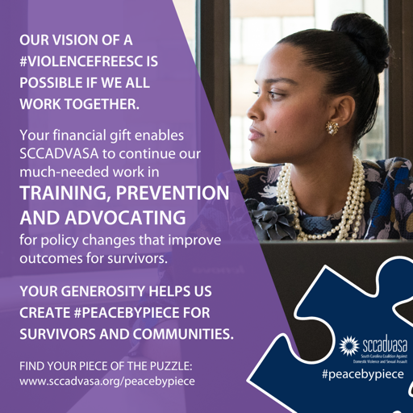

Providing slightly different IMAGES & MESSAGES for individuals to use on Giving Tuesday.

- Prevention Work

Community leaders and educators are a critical piece of the puzzle to bring peace to survivors. Their commitment to education and violence prevention initiatives means a brighter future for the next generation. Donate now to support @SCCADVASA’s prevention work that brings #peacebypiece within local S.C. communities. https://www.sccadvasa.org/donate/

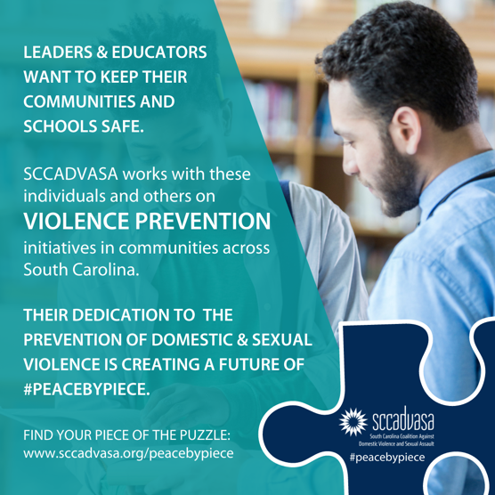

- Systems Advocate

Engaging marginalized communities of color is critical to this work. By utilizing a trauma-informed lens and taking a holistic and intersectional approach, @SCCADVASA is better informing its work and efforts in bringing survivors #peacebypiece. Donate today to support a #ViolenceFreeSC for all. https://www.sccadvasa.org/donate/
